Flight Booking Web Application

**REPORT**

**Team Members:**

ANONANCIYA ROSE M : Full Stack Developer  
MITHRA Y : Full Stack Developer  
PAVITHRA M : Full Stack Developer

SNOWVITA B : Full Stack Developer

**Project Overview:**

**Purpose:**

The Flight Booking Web Application is designed to transform the traditional process of booking flights into a streamlined, user-friendly digital experience. The platform provides travelers with a seamless way to search for flights, reserve tickets, and manage their bookings, all from the comfort of their devices. By automating and digitizing the booking process, the application reduces the hassle of manual reservations and ensures a faster, more efficient user experience.

Beyond just a booking system, the application also empowers administrators with comprehensive tools to oversee the entire process. This includes managing flight schedules, updating seat availability, and overseeing customer bookings. The ultimate goal is to create a versatile and reliable platform that benefits both travelers looking for convenience and administrators seeking efficient operational control.

**Features:**

* **User Authentication:** A secure registration and login system ensures user data protection while granting access only to authorized users.
* **Flight Search with Advanced Filters:** Users can filter flights by parameters like departure city, destination, travel dates to find the best options.
* **Flight Booking & Interactive Seat Selection:** A smooth booking process where users can reserve tickets and select seats through an interactive seat map for a personalized experience.
* **Comprehensive Admin Dashboard:** Admins have a centralized dashboard to manage flights, update schedules, review bookings, and oversee customer accounts.
* **Real-Time Updates on Flight Availability:** The system continuously syncs to provide users with the most up-to-date seat availability and flight status for informed decision-making.
* **Flight Operator Management:** Flight operators can add new flight details, including flight schedules and seat availability, and also edit or update existing flight information.

**Architecture:**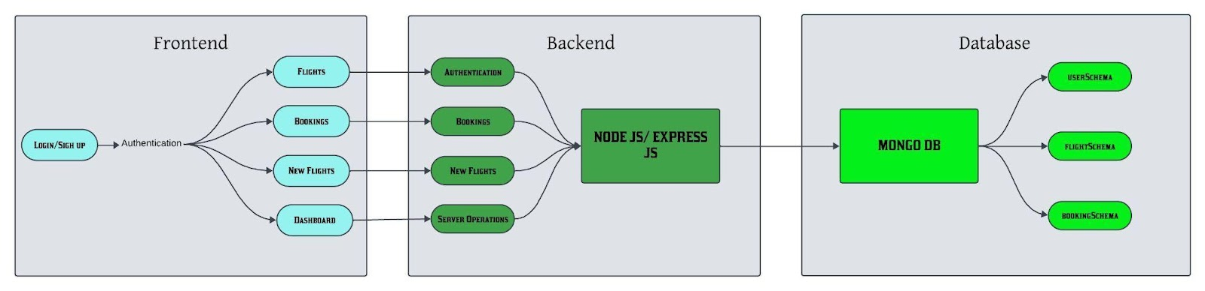

1. **Frontend:**

The frontend is developed using React.js. It handles user authentication, flight searches, bookings, and provides a dynamic and responsive user interface.

* **Authentication Pages:**
  + Login and Register Forms
* **Customer Views:**
  + **Flight Search & Booking:** Search, view, and book flights.
  + **Booking History:** View past and present bookings, cancel tickets.
* **Flight Operator Views:**
  + **Flight Management:** Add, edit, delete flight details.
  + **Booking View:** View bookings for the operator’s flights.
* **Admin Dashboard:**
  + **User Management:** Approve or deny flight operator registration.
  + **Flight Management:** View, add, edit, or delete flights.
  + **Booking Overview:** Access all bookings made across the platform.
  + **User Overview:** View all users (flight operators and customers).

1. **Backend:**  
   The backend is built using Node.js and Express.js. It handles:

* User authentication.
* CRUD operations for flights and bookings.
* Secure handling of user data and interactions.
* Routes for handling APIs related to flights, users, and admin activities.

1. **Database:**

The database uses MongoDB for data storage. Collections include:

* User Schema
* Flight Schema
* Booking Schema

**Setup Instructions:**

1. **Prerequisites:**

* Node.js (v14.17.0 or higher)
* MongoDB (local or cloud-based using MongoDB Atlas)
* npm (Node Package Manager)
* React (Frontend framework)
* Two web browsers (recommended: Chrome and Firefox)

1. **Installation:**

* Clone the repository:  
   **git clone <repository-url>  
   cd flight-booking-app\**
* Install dependencies for the server:  
   **cd server  
   npm install**
* Install dependencies for the client:  
   **cd ../client  
   npm install**

**Folder Structure:**

1. **Server (Node.js Backend, MongoDB Database)**

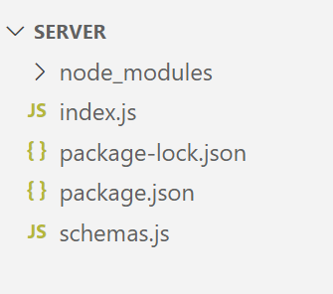

1. **Client (React js):**

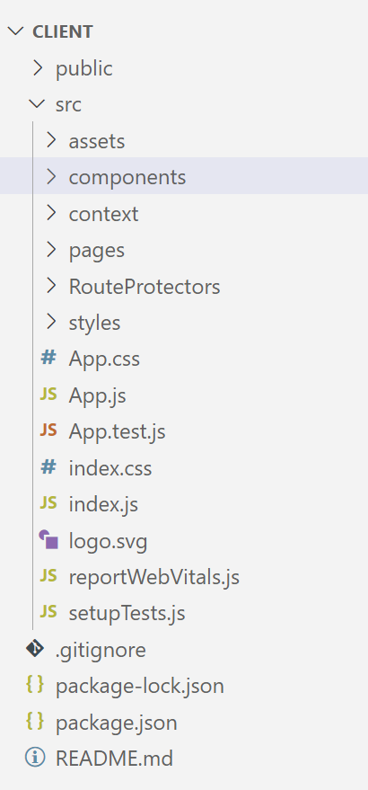

**Running the Application:**

1. **Frontend:**

* Navigate to the client directory and run:  
   **npm start**

1. **Backend:**

* Navigate to the server directory and run:  
   **node index.js**

**API Documentation:**

### **Register Endpoint:**

* **URL:** /register
* **Method:** POST
* **Description:** Registers a new user by saving their details to the database.
* **Authentication:** None (data is fetched from the backend directly).
* **Request Parameters:**
  + **Body Parameters:**
    - email (required) - The email of the user.
    - password (required) - The password of the user.
    - username (required) - The name of the user.
    - usertype (required) - The type of user (customer, admin, flight-operator).
* **Response Example:**
  + **Success Response (201 Created):**

{

"_id": "654321",

"usertype": "customer",

"username": "WXYZ",

"email": "newuser@example.com"

}

1. **Login Endpoint:**

* **URL:** /login
* **Method:** POST
* **Description:** Authenticates the user by verifying their email and password, and returns their user data if valid.
* **Authentication:** None (data is fetched from the backend directly).

#### **Request Parameters:**

* + **Body Parameters:**
    - email (required) - The email of the user.
    - password (required) - The password of the user.
* **Response Example:**
  + **Error Response (401 Unauthorized):**

{

"error": "Invalid email or password"

}

### **Fetch Users Endpoint:**

### **URL:** /fetch-users

* **Method:** GET
* **Description:** Retrieves the list of users from the database.
* **Authentication:** None (data is fetched from the backend directly).
* **Request Parameters:** None
* **Response Example:**
  + **Success Response (200 OK):**

{

"_id": "12345",

"username": "John Doe",

"email": "johndoe@example.com",

"approval": "not-approved"

}

1. **Fetch Bookings Endpoint:**

* **URL:** /fetch-bookings
* **Method:** GET
* **Description:** Retrieves the list of bookings from the database.
* **Authentication:** None (data is fetched from the backend directly).
* **Request Parameters:** None
* **Response Example:**
  + **Success Response (200 OK):**

{

"bookingId": "B12345",

"userId": "12345",

"flightId": "F123",

"status": "confirmed"

}

### **Fetch Flights Endpoint:**

* **URL:** /fetch-flights
* **Method:** GET
* **Description:** Retrieves the list of flights from the database.
* **Authentication:** None (data is fetched from the backend directly).
* **Request Parameters:** None
* **Response Example:**
  + **Success Response (200 OK):**

{

"flightId": "F123",

"flightName": "Flight A",

"departure": "2024-12-01T10:00:00",

"arrival": "2024-12-01T12:00:00"

}

### **Approve Operator Request Endpoint:**

* **URL:** /approve-operator
* **Method:** POST
* **Description:** Approves a flight operator by their id.
* **Authentication:** Required (assumed based on the app's flow, you may need token-based authentication or user validation).
* **Request Parameters:**
  + **Body Parameters:**
    - id (required) - The unique ID of the operator to be approved.
* **Response Example:**
  + **Success Response (200 OK):**  
    {

"message": "Operator approved successfully"

}

1. **Reject Operator Request Endpoint:**

* **URL:** /reject-operator
* **Method:** POST
* **Description:** Rejects a flight operator by their id.
* **Authentication:** Required
* **Request Parameters:**
  + **Body Parameters:**
    - id (required) - The unique ID of the operator to be rejected.
* **Response Example:**
  + **Success Response (200 OK):**  
    {

"message": "Operator rejected successfully"

}

### **Cancel Ticket Endpoint:**

* **URL:** /cancel-ticket/{id}
* **Method:** PUT
* **Description:** Cancels a ticket based on the provided booking ID.
* **Authentication:** Required
* **Request Parameters:**
  + **URL Parameters:**
    - id (required) - The unique ID of the booking that needs to be canceled.
* **Response Example:**
  + **Success Response (200 OK):**

{

"message": "Ticket canceled successfully"

}

1. **Book Flight Endpoint:**

* **URL:** /book-ticket
* **Method:** POST
* **Description:** Books a flight ticket for a user, providing the necessary details such as flight, passenger, and payment information.
* **Authentication:** Required
* **Request Parameters:**
  + **Body Parameters:**
    - user (required) - The unique ID of the user
    - flight (required) - The flight ID that the user is booking.
    - flightName (required) - The name of the flight.
    - flightId (required) - The ID of the flight.
    - departure (required) - The departure city.
    - journeyTime (required) - The departure time of the flight.
    - destination (required) - The destination city.
    - email (required) - The email address of the user.
    - mobile (required) - The mobile number of the user.
    - passengers (required) - The details of the passengers (e.g., name, age, etc.).
    - totalPrice (required) - The total cost of the booking.
    - journeyDate (required) - The date of the flight journey.
    - seatClass (required) - The class of the seat (e.g., "coach", "business").
* **Response Example:**
  + **Success Response (200 OK):**

{

"message": "Booking successful"

}

### **Update Flight Endpoint:**

* **URL:** /update-flight
* **Method:** PUT
* **Description:** Updates the details of an existing flight in the system.
* **Authentication:** Required (assumed based on the app's flow, you may need token-based authentication or user validation).
* **Request Parameters:**
  + **Body Parameters:**
    - _id (required) - The unique ID of the flight to be updated.
    - flightName (required) - The name of the flight.
    - flightId (required) - The ID of the flight.
    - origin (required) - The departure city for the flight.
    - destination (required) - The destination city for the flight.
    - departureTime (required) - The scheduled departure time of the flight.
    - arrivalTime (required) - The scheduled arrival time of the flight.
    - basePrice (required) - The base price of the flight.
    - totalSeats (required) - The total number of available seats for the flight.
* **Response Example:**
  + **Success Response (200 OK):**

{

"message": "Flight updated successfully"

}

1. **Fetch User Data Endpoint**

* **URL:** /fetch-user/{id}
* **Method:** GET
* **Description:** Fetches the details of a specific user based on the user ID.
* **Authentication:** Required.
* **Request Parameters:**
  + **URL Parameters:**
    - id (required) - The unique ID of the user whose data needs to be fetched.
* **Response Example:**
  + **Error Response (500 Internal Server Error):**

{

"error": "Failed to fetch user data"

}

**Authentication:**

Authentication in this project is managed through a simple user login system.

* **User Login and Registration:** Users can create an account with a username, password, and email. The credentials are securely stored in the database.
* **Middleware:** Basic authentication middleware is used to check if a user is logged in before accessing certain protected routes.
* **Role-Based Access:** The system differentiates between regular users and admin users using a usertype field in the user schema, allowing the admin to manage flights and bookings.

**User Interface:**

**Home Page:**



**Footer Layout:**

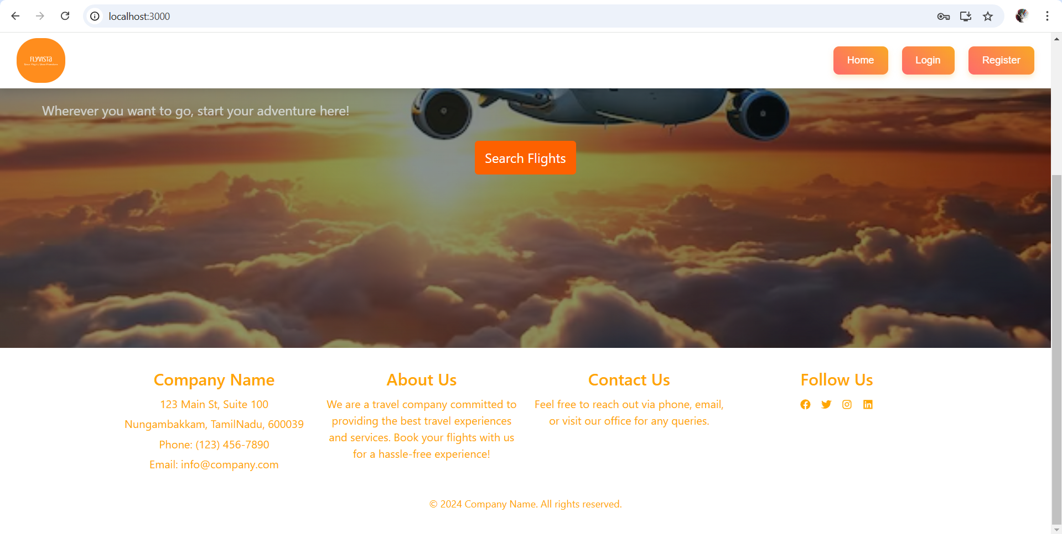

**Login Page:**

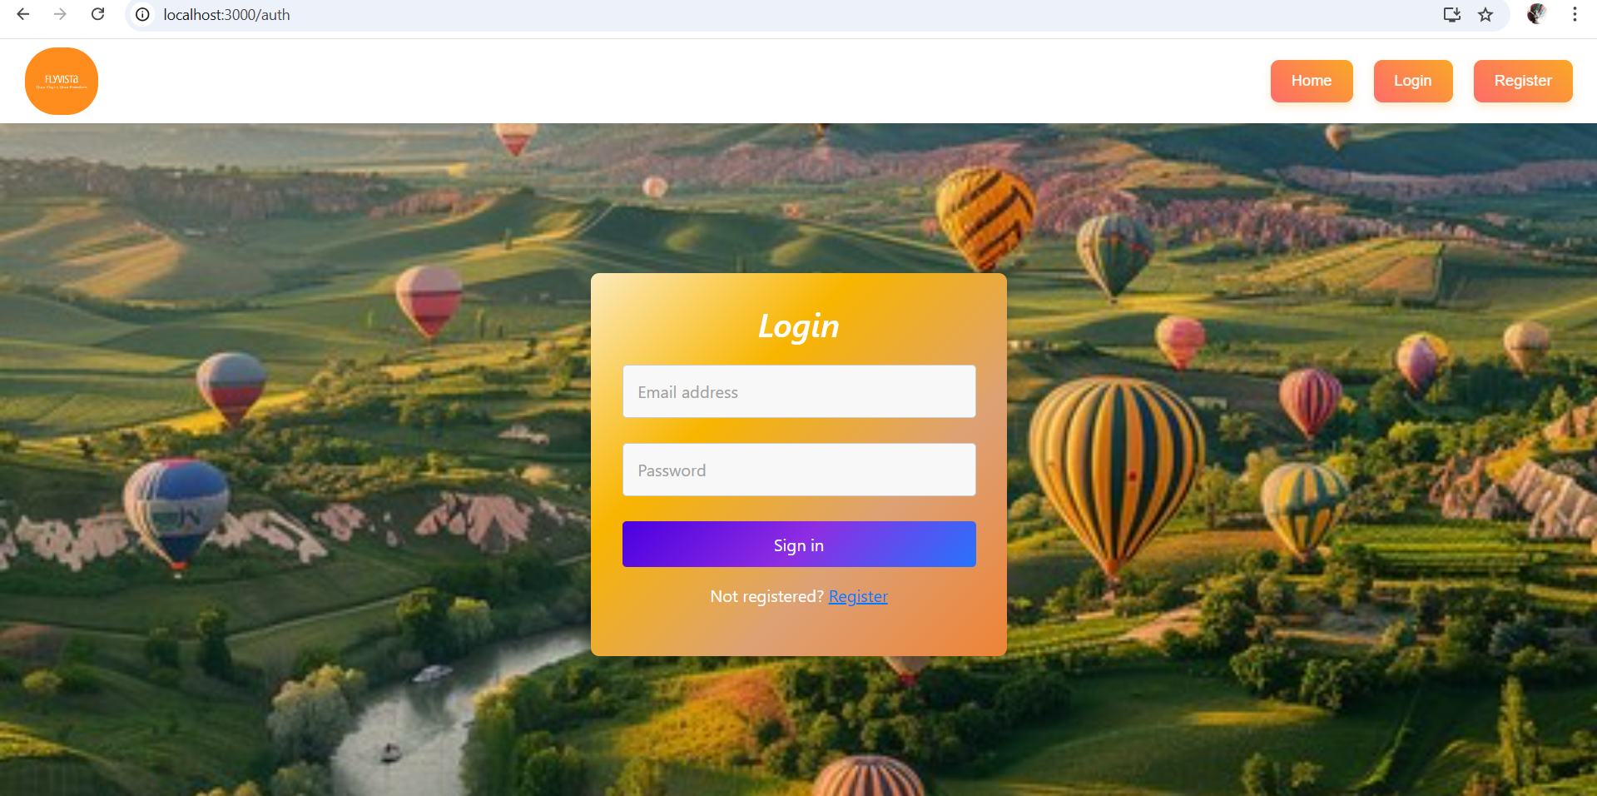

**Register Page:**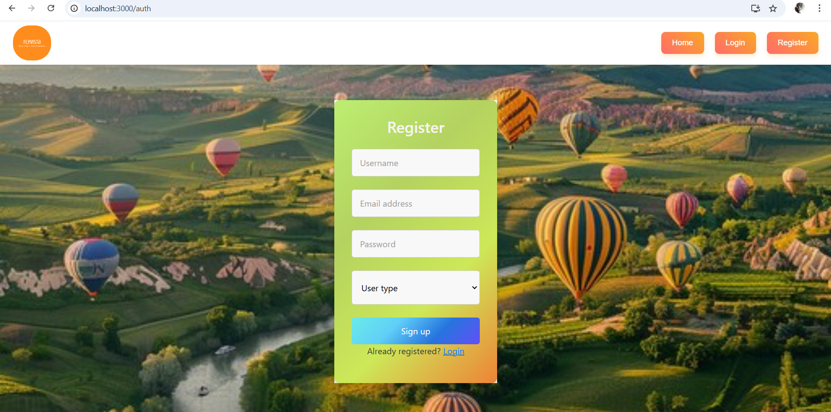

**Admin Dashboard:**

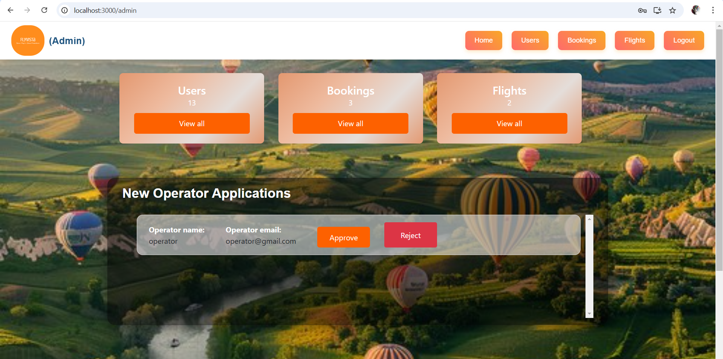

**Operator Dashboard:**

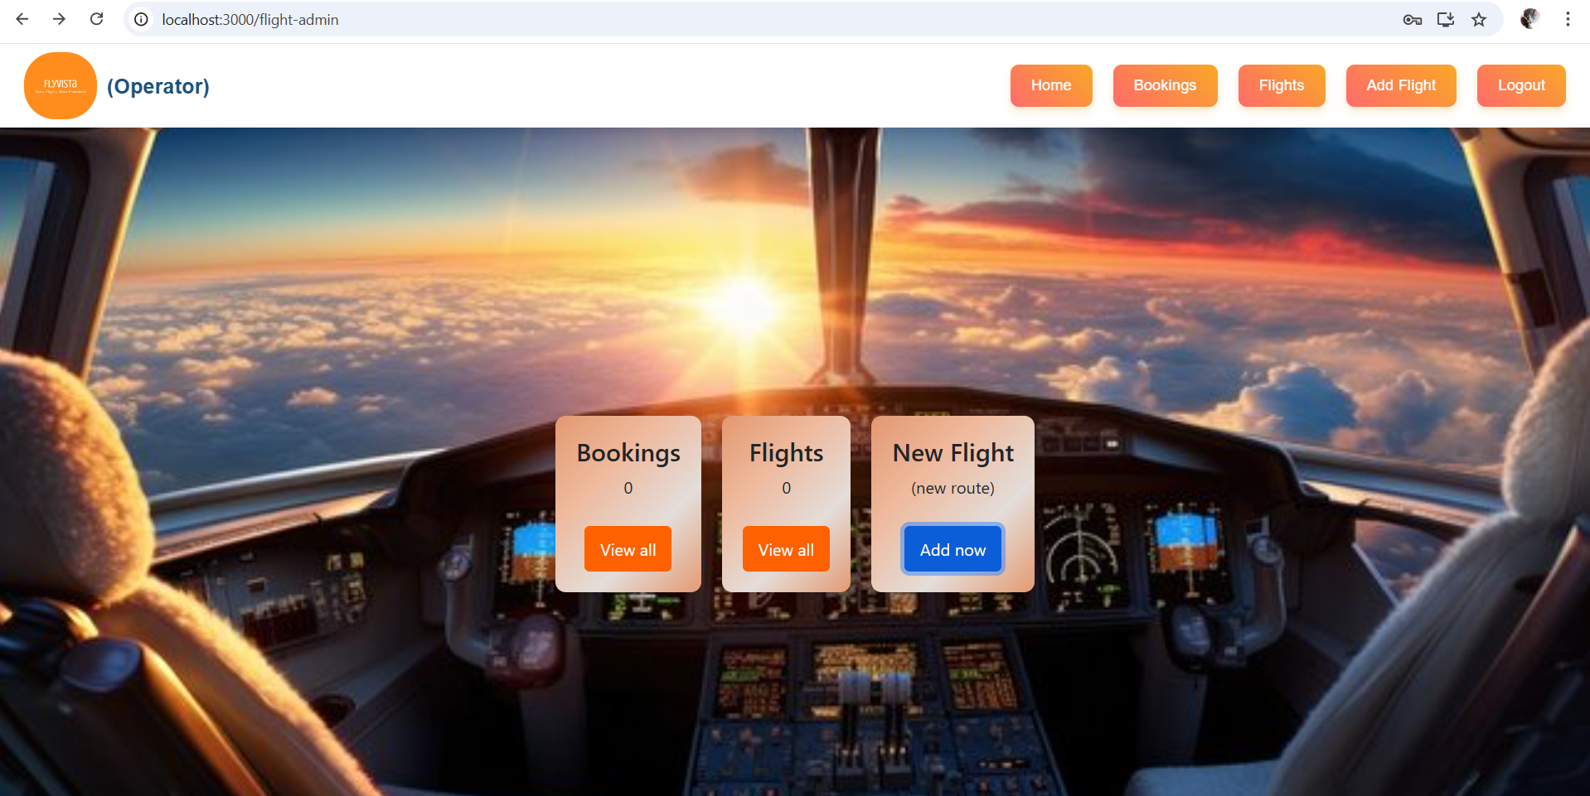

**User Dashboard:**

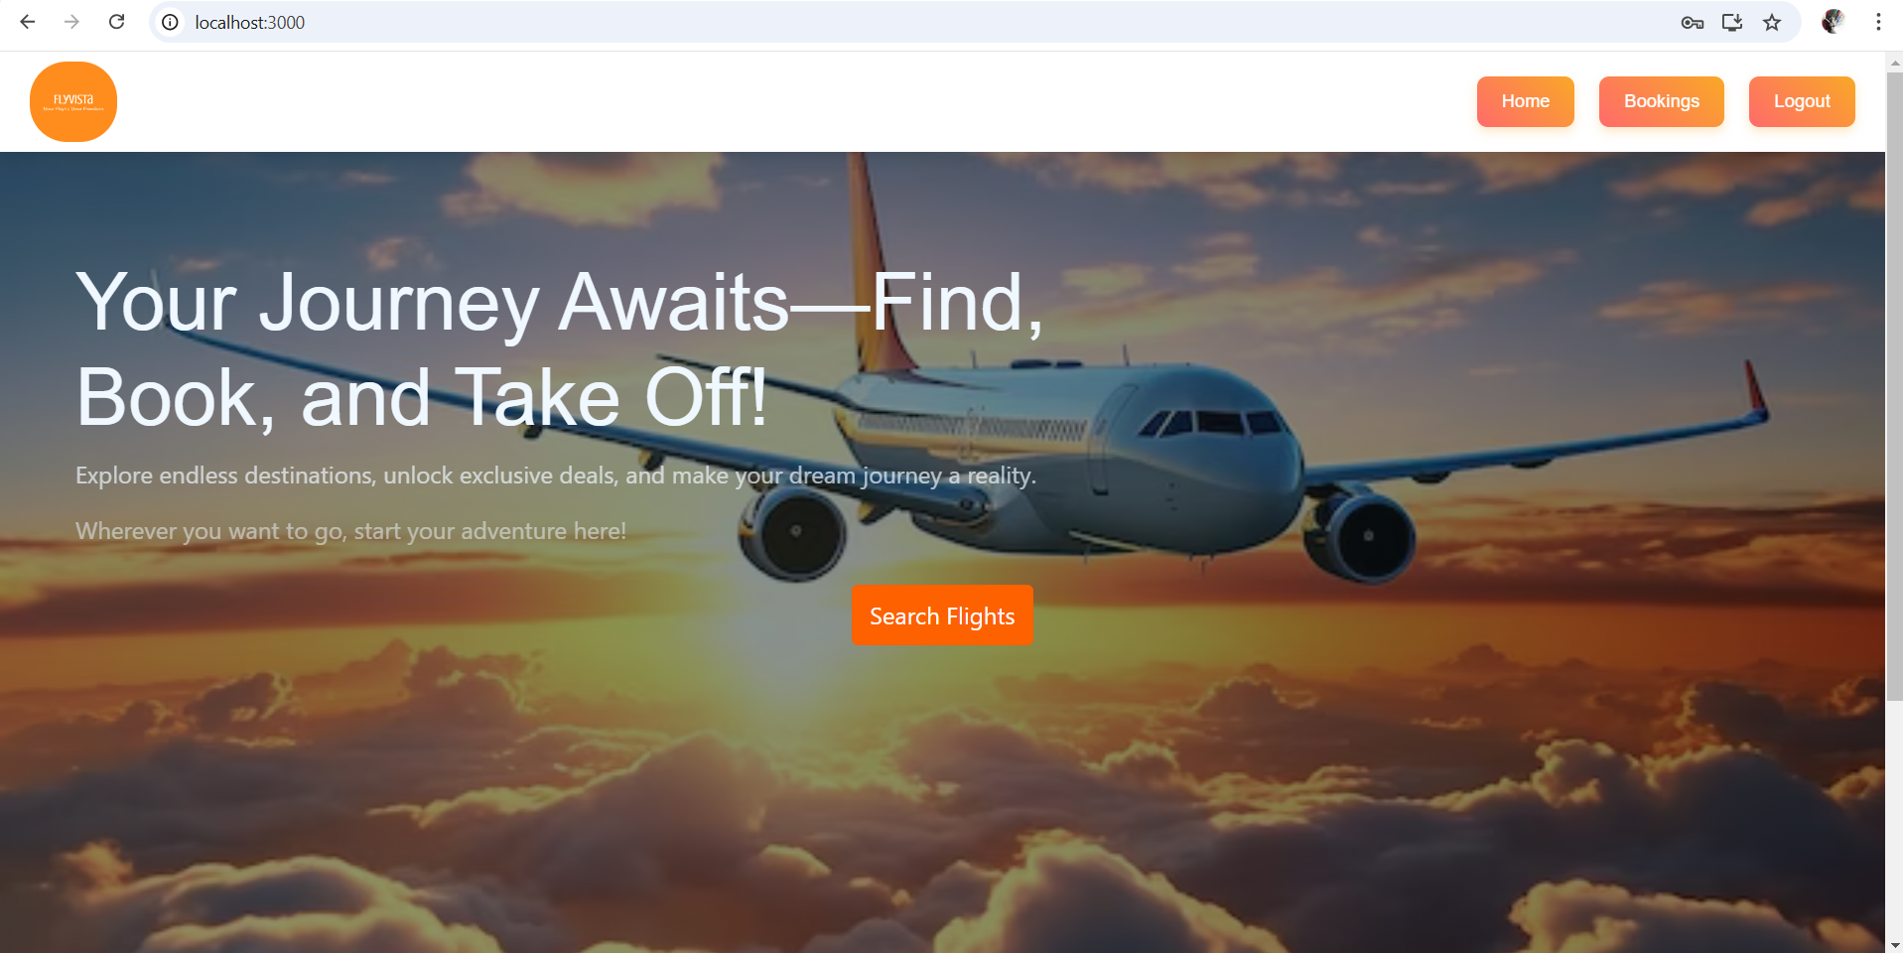

**User Details Page:**

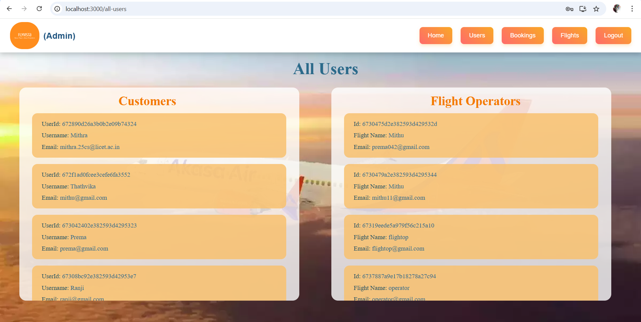

**Bookings Details Page:**

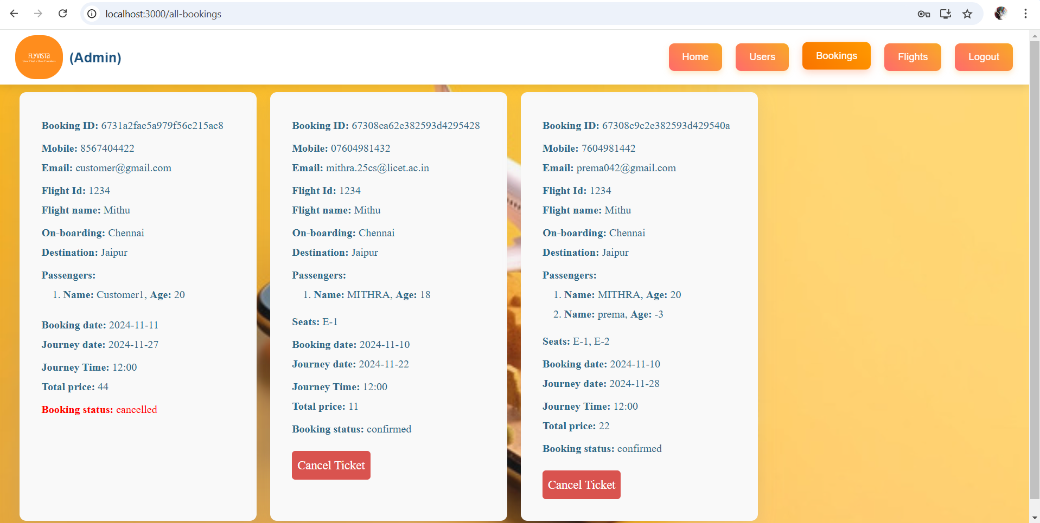

**Flight Creation Page:**

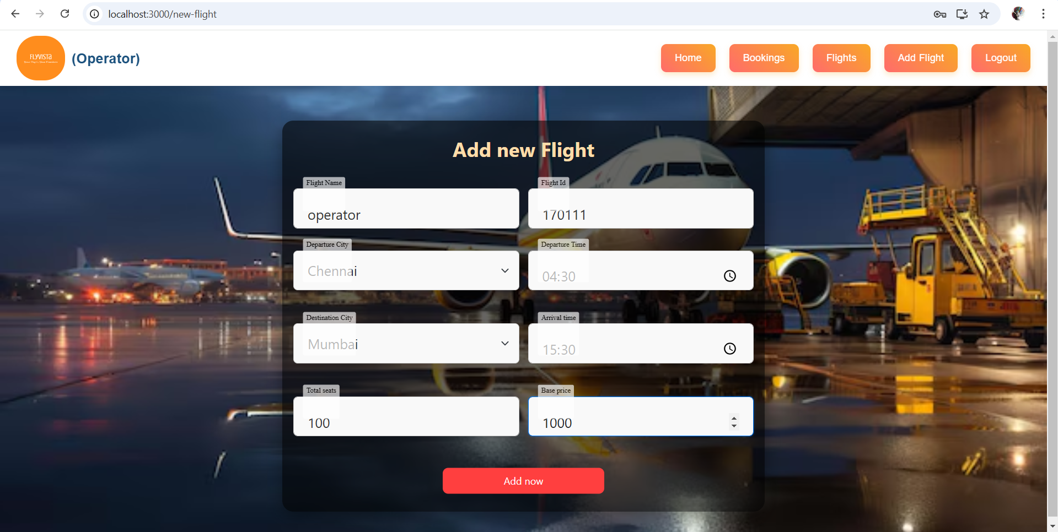

**Flight Details Page:**

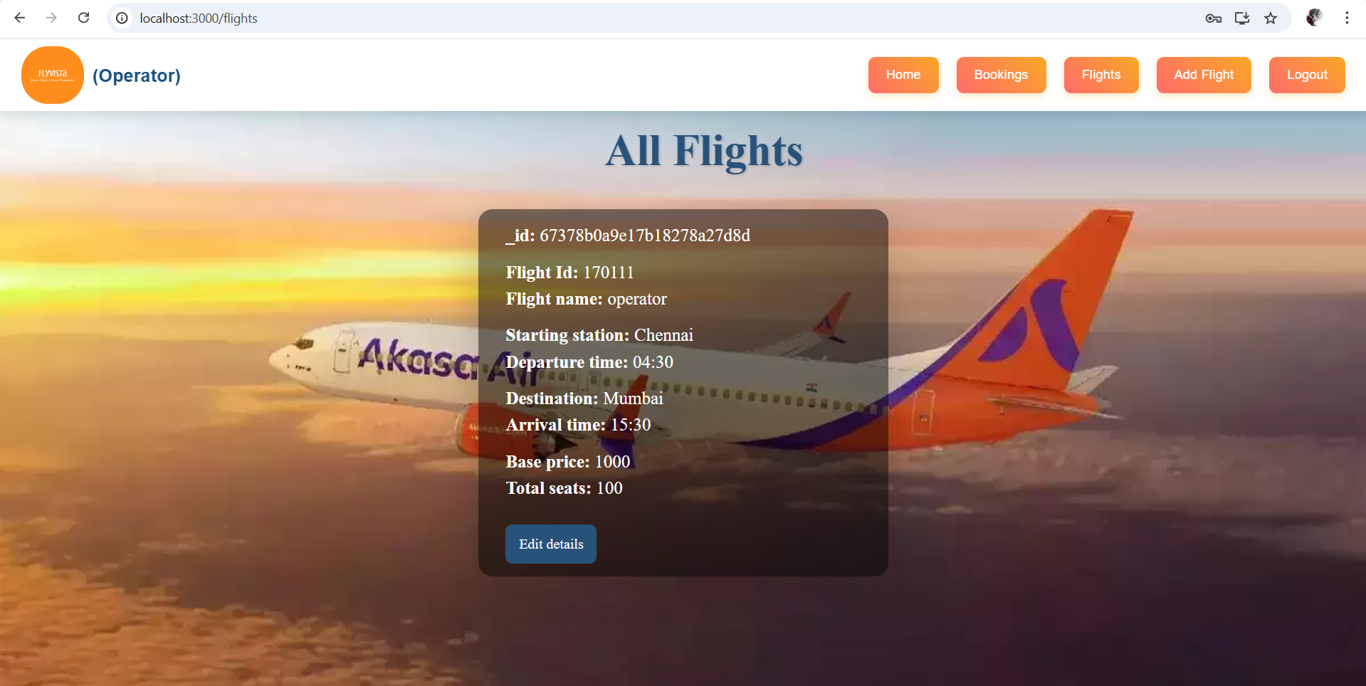

**Search Flights Modal:**

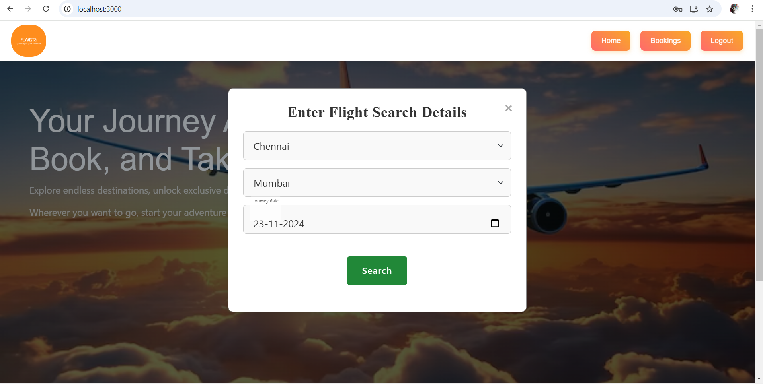

**Flight Details Modal:**

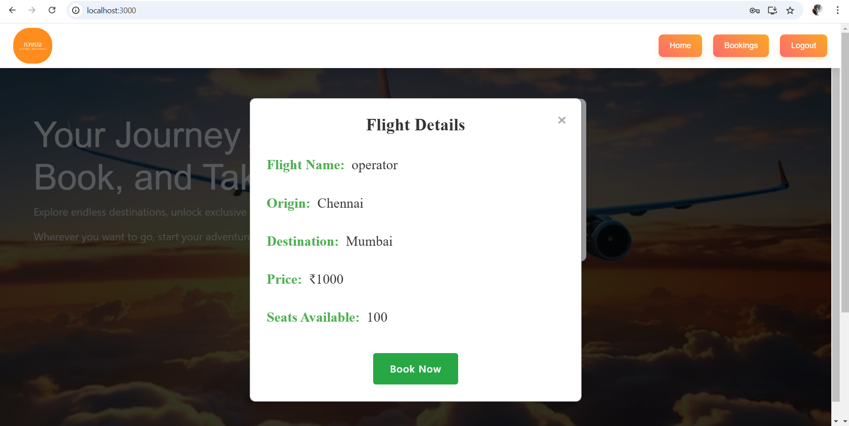

**Testing:**

The Testing Strategies and tools used in the project are:

1. **Manual Testing**:

* Test key user flows such as registration, booking, admin actions, and cancellations.
* Ensure that all user types (Customer, Flight Operator, Admin) can perform their respective tasks correctly.
* Verify the UI for usability and functionality.

1. **Unit Testing (with Jest)**:

* Test individual backend functions like user registration, login, flight management, and booking operations.
* Mock database interactions to isolate logic and test edge cases (e.g., incorrect data, missing fields).

1. **Integration Testing**:

* Ensure proper communication between APIs and the database, validating that data is correctly stored, retrieved, and updated.
* Test the full flow of user actions, ensuring the backend and database work together as expected.

**Demo Link:**

[**Project Demonstration video with explanation**](https://drive.google.com/file/d/1WB8hwNrunLVtmWjmTCq42FHOA9IF4Xrq/view?usp=sharing)

**Known Issues:**

* Multiple users booking the same flight can lead to double bookings. Proper locking or transaction management is needed to handle concurrency.
* Users may see incorrect seat availability due to delayed updates. Real-time updates and consistent syncing are required to prevent this.
* Large databases can slow down flight searches and bookings. Optimizing queries and using caching can improve response times.
* Session issues may cause users to lose progress or get logged out unexpectedly. Consistent session management is essential across devices.
* Edge cases like payment failures need graceful handling to avoid system crashes. Robust error handling ensures smooth recovery and user feedback.

**Future Enhancements:**

* Developing a mobile application using React Native will allow users to access the platform on their smartphones, enhancing accessibility and user experience.
* Implementing SMS notifications can improve user engagement by providing timely updates on booking confirmations, cancellations, or flight changes.
* Integrating payment gateways will offer users more payment options, making the booking process smoother and more flexible.
* Using AI/ML for flight recommendations can personalize the user experience by suggesting flights based on preferences, previous bookings, or travel patterns.
* Load testing will ensure the platform can handle high traffic volumes, maintaining performance and reliability during peak usage times.